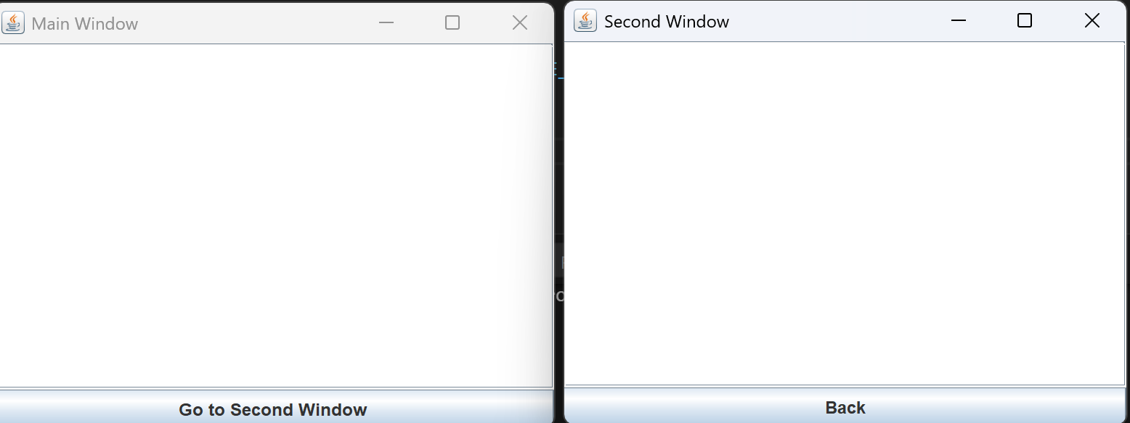
import javax.swing.*;
import java.awt.*;
import java.awt.event.*;
import java.io.*;

public class Main {

// Глобальная переменная для передачи текста между окнами
public static String globalText = "";

public static void main(String[] args) {
SwingUtilities.invokeLater(() -> new MainWindow().setVisible(true));
}

// Главное окно
static class MainWindow extends JFrame {
private JTextArea textArea;
private JButton nextButton;
private static final String FILE_NAME = "saved_text.txt";

public MainWindow() {
setTitle("Main Window");
setSize(400, 300);
setDefaultCloseOperation(JFrame.EXIT_ON_CLOSE);
setLocationRelativeTo(null);
setLayout(new BorderLayout());

textArea = new JTextArea();
add(new JScrollPane(textArea), BorderLayout.CENTER);

nextButton = new JButton("Go to Second Window");
add(nextButton, BorderLayout.SOUTH);

// Загрузка текста из файла
String savedText = readFromFile();
if (savedText != null) {
textArea.setText(savedText);
globalText = savedText;
}

// Кнопка перехода
nextButton.addActionListener(e -> {
globalText = textArea.getText();
new SecondWindow().setVisible(true);
});

// Сохраняем текст при закрытии
addWindowListener(new WindowAdapter() {
@Override
public void windowClosing(WindowEvent e) {
writeToFile(textArea.getText());
}
});
}

private void writeToFile(String text) {
try (FileOutputStream fos = new FileOutputStream(FILE_NAME)) {
fos.write(text.getBytes());
} catch (IOException e) {
e.printStackTrace();
}
}

private String readFromFile() {
try (FileInputStream fis = new FileInputStream(FILE_NAME)) {
byte[] buffer = fis.readAllBytes();
return new String(buffer);
} catch (IOException e) {
return null;
}
}
}

// Второе окно
static class SecondWindow extends JFrame {
private JTextArea textArea;
private JButton backButton;
private static final String FILE_NAME = "saved_text.txt";

public SecondWindow() {
setTitle("Second Window");
setSize(400, 300);
setLocationRelativeTo(null);
setLayout(new BorderLayout());

textArea = new JTextArea(globalText);
add(new JScrollPane(textArea), BorderLayout.CENTER);

backButton = new JButton("Back");
add(backButton, BorderLayout.SOUTH);

backButton.addActionListener(e -> {
globalText = textArea.getText();
writeToFile(globalText);
dispose(); // закрываем окно
});

// Сохраняем текст при закрытии окна
addWindowListener(new WindowAdapter() {
@Override
public void windowClosing(WindowEvent e) {
globalText = textArea.getText();
writeToFile(globalText);
}
});
}

private void writeToFile(String text) {
try (FileOutputStream fos = new FileOutputStream(FILE_NAME)) {
fos.write(text.getBytes());
} catch (IOException e) {
e.printStackTrace();
}
}
}
}

